

Data Warehousing & Mining Lab

Assignment

Lab - 2

Sub Code: CSE-326

Date: 21-01-2022

**Vivek Kumar Ahirwar**

**191112419**

**CSE - 3**

Department:

*Computer Science and Engineering*

**Contents**

A. Consider the sample data set (Sample.csv file Review the following attributes of the data set). Convert this into My SQL table: 2

i. Upload data to GIS cloud 2

ii. Create a map – 4

iii. Data styling and classification – 5

iv. Share , embed and publish your map – 6

v. Select and Export Data – 6

# Consider the sample data set (Sample.csv file Review the following attributes of the data set). Convert this into My SQL table:

### Upload data to GIS cloud

Login to your GIS Cloud account and enter the Map Editor application. There you can do all sorts of stuff with your location data.

To upload the data navigate to the tools section and open the File Manager. Just drag and drop the data in the box and that is it.

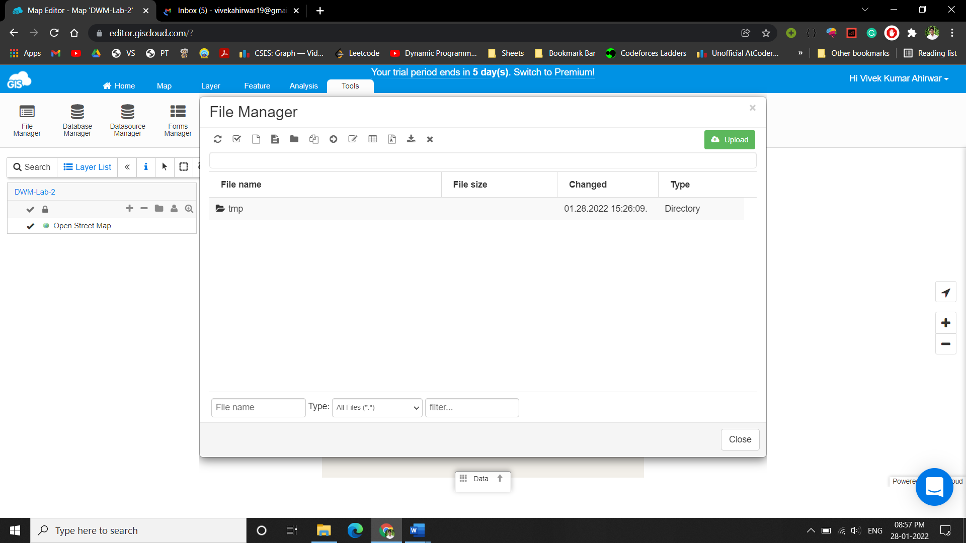

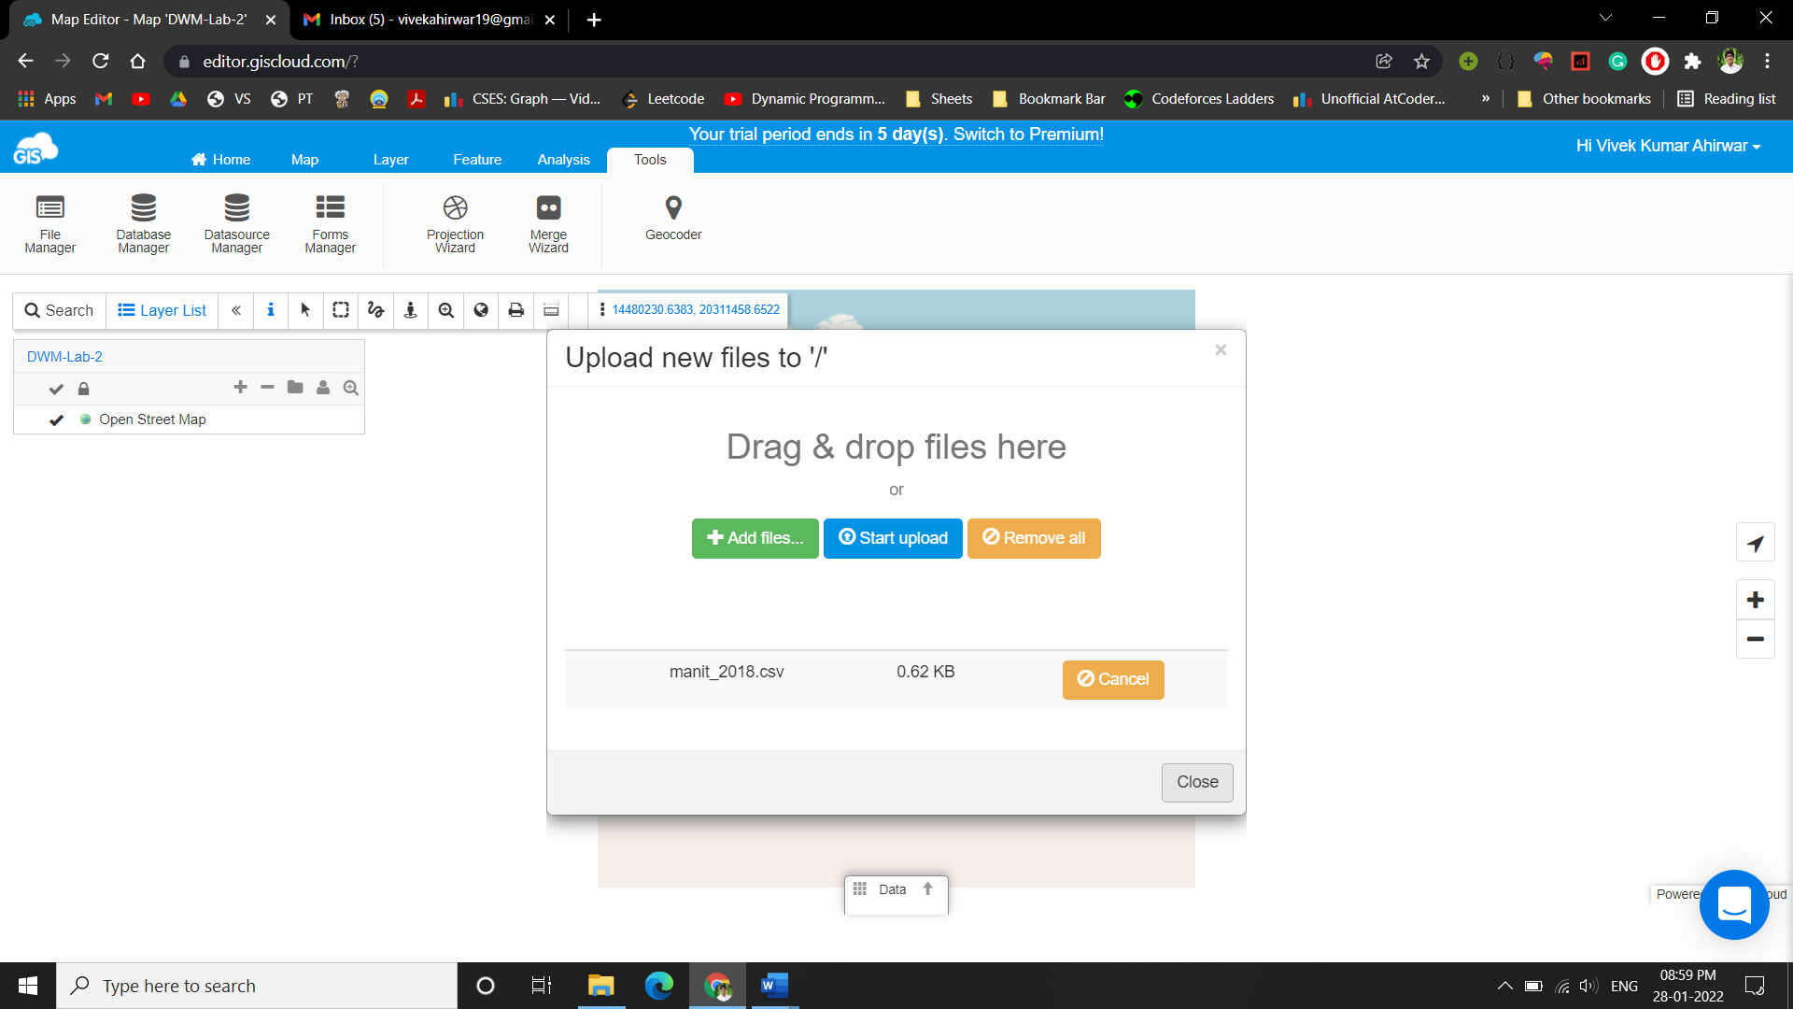

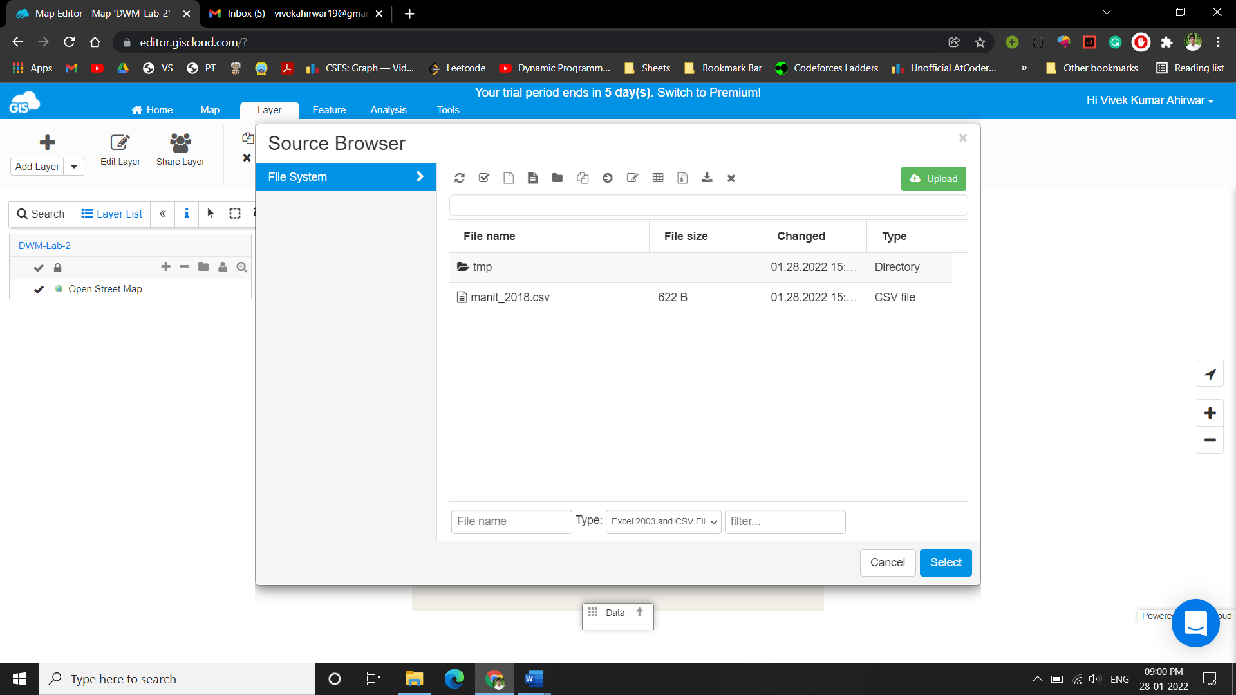

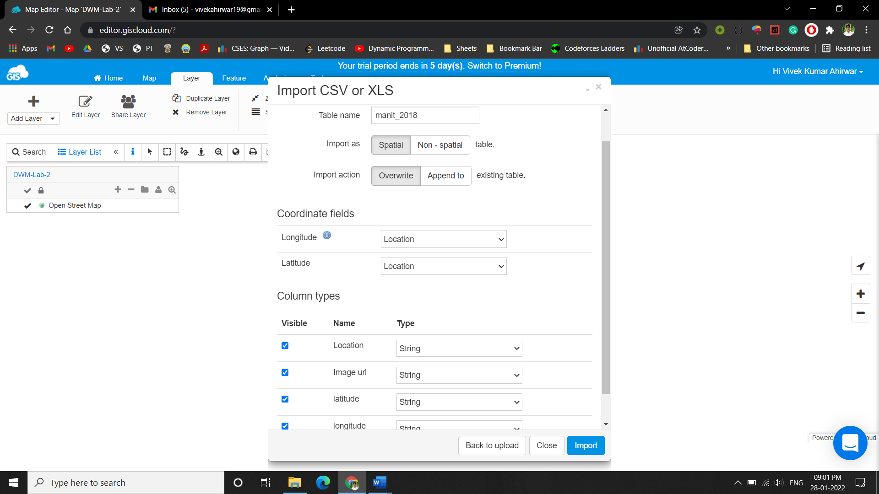

### Create a map –

Now that you have uploaded the data you’ll need to create a map. Click on the Create New Map button, name your map and choose the basemap.

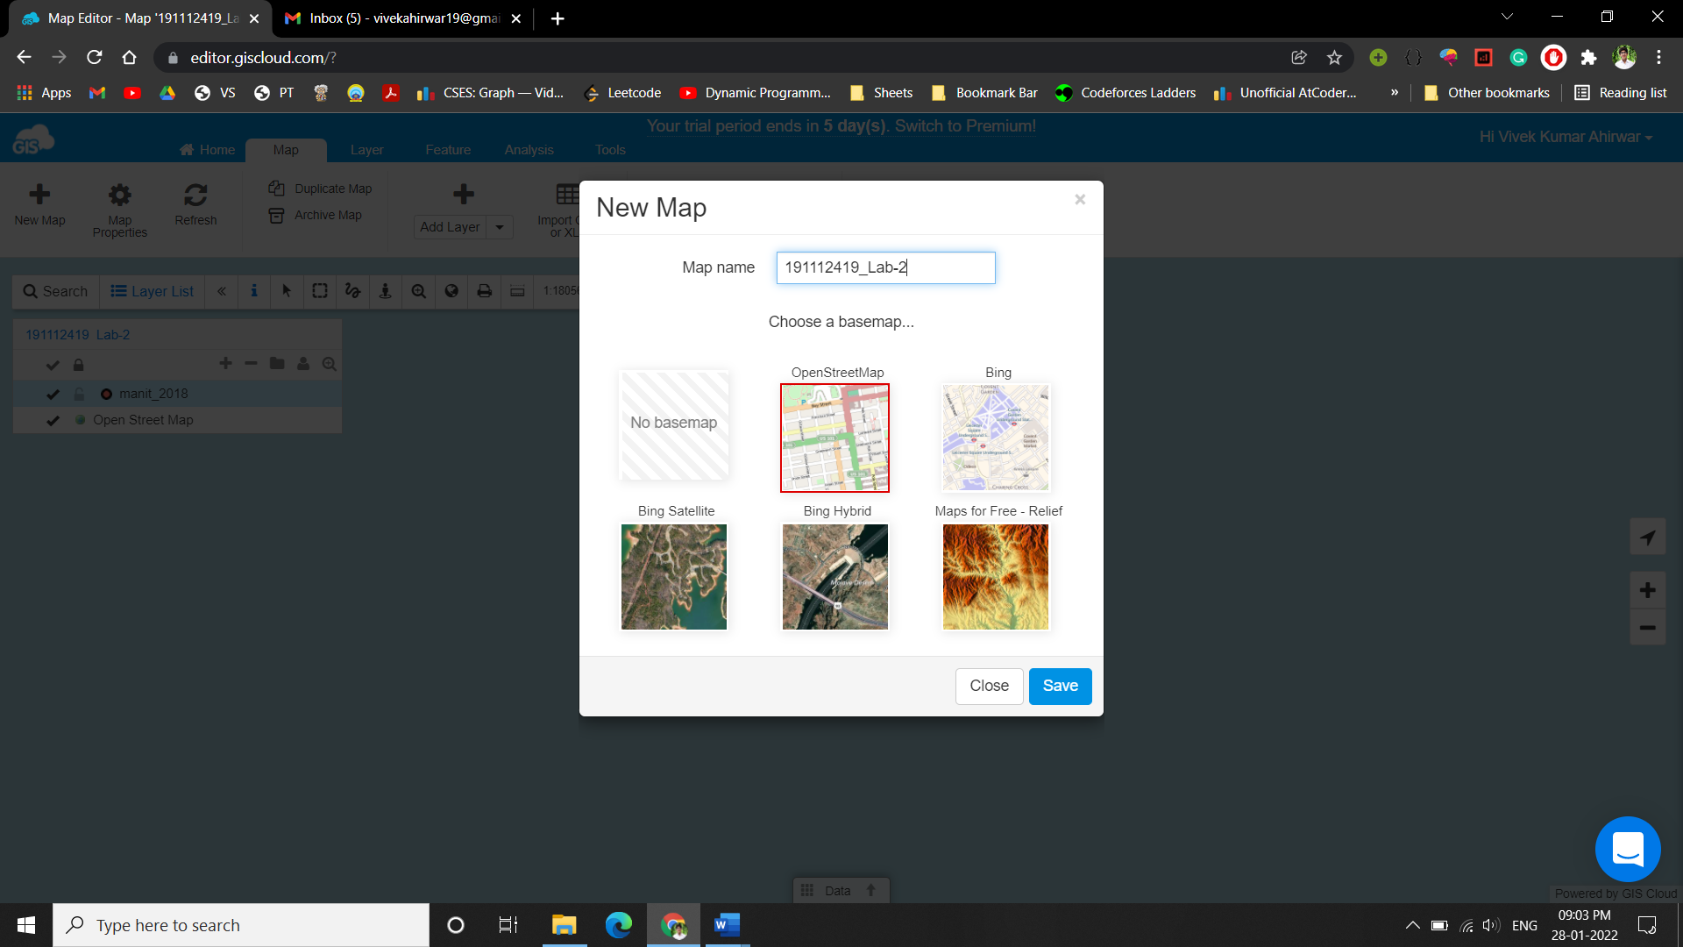

The next step is to add your data to the map. Click on Add Layer and select the desired file. You can also add data from the database.

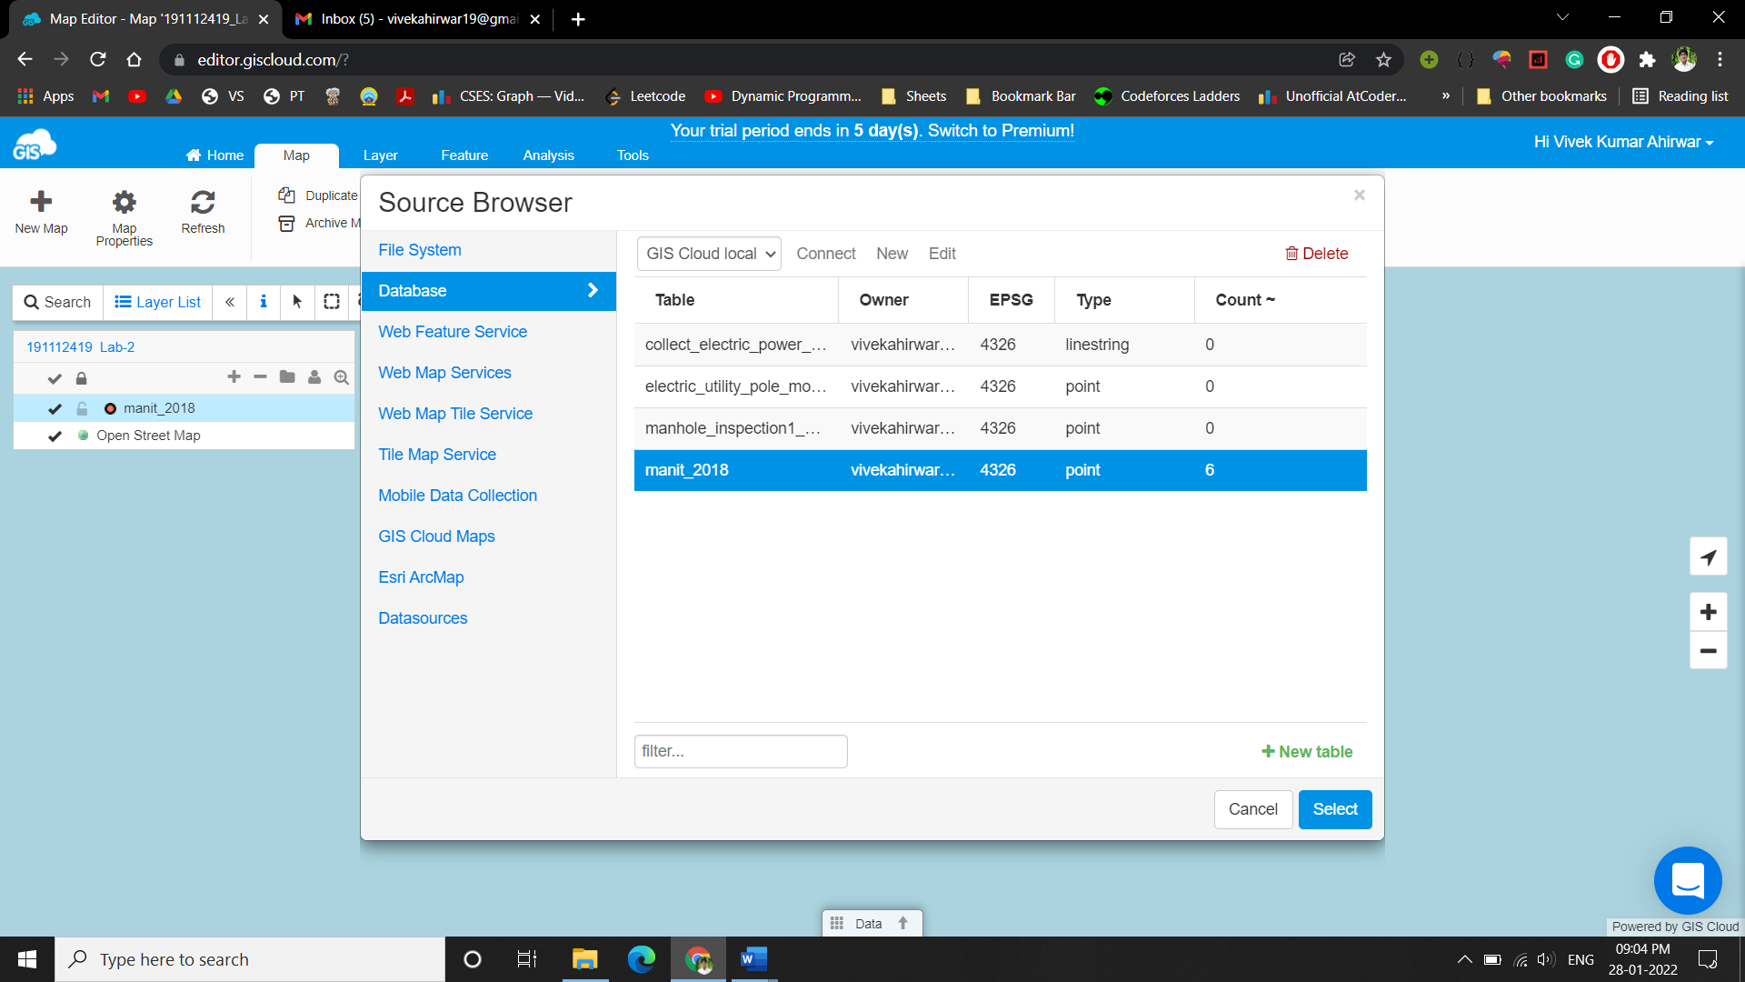

As soon as you upload the file, the data is visualized on a map and ready for editing and sharing.

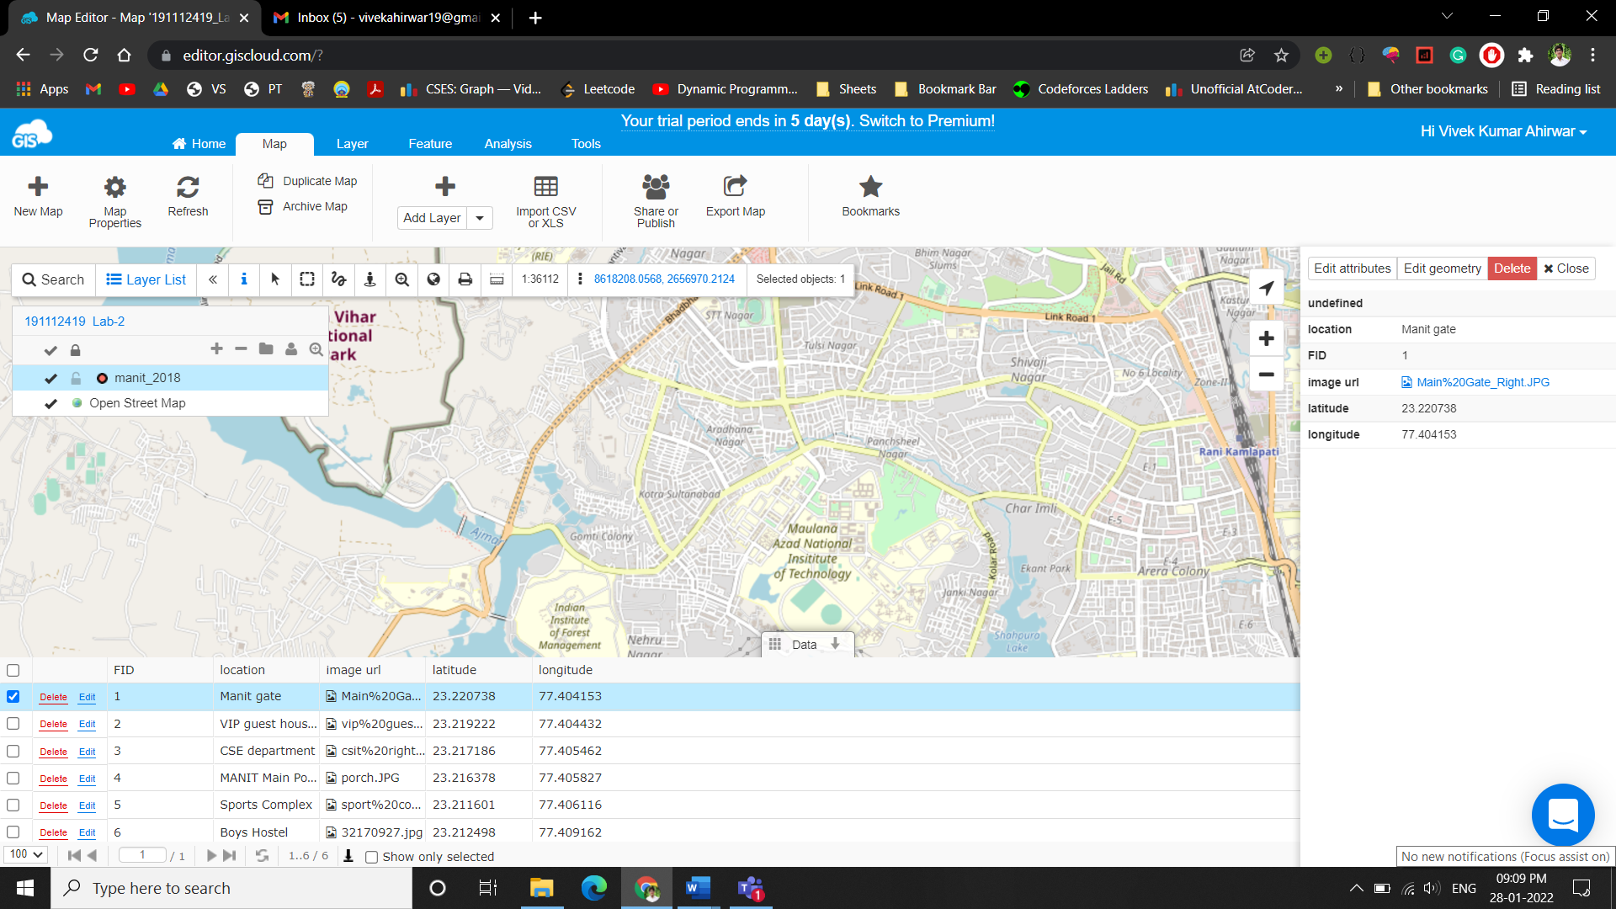

### Data styling and classification –

GIS Cloud has powerful features for data styling that can help you create a stunning map.

• Apply colours and icons based on your data.

• Create an intensity map for countries, states or provinces.

• Turn data into a map that tells the story visually.

### Share , embed and publish your map –

With GIS Cloud you can share maps with people that also have an account or publish a map to make it accessible to anyone. It is also possible to embed the map to a third party website, just copy the embed code into an iframe.

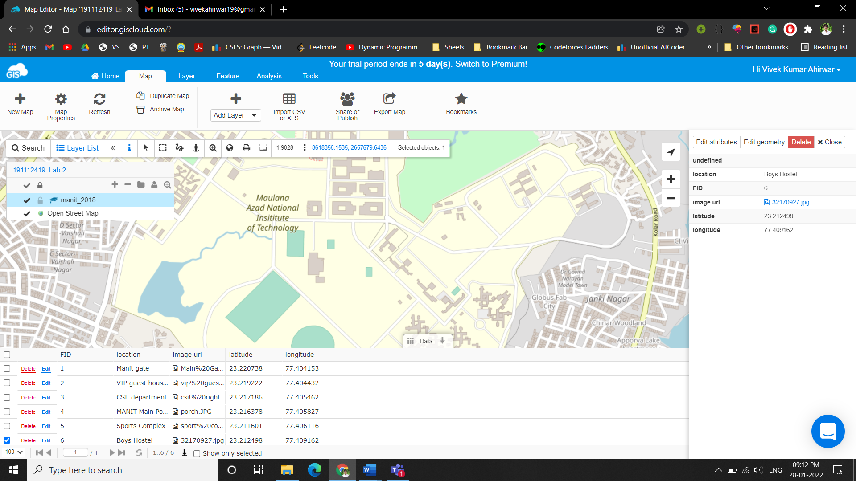

### Select and Export Data –

There are many ways to select the data you want to export. From simple tools like area selection or freehand selection to more complex tools like the spatial selection.

**Area selection-**

Select the layer from the Layer List. Click the Area Select tool on the Toolbar. Drag a box to define the area of selected features.

**Freehand selection-**

Similar to area selection but instead of dragging a box you draw the area you want to select.

Selecting data in the grid (data filtering)-

Data filtering tool allows you to filter, find and visualize features by its attributes. After filtering the data grid, you can export the filtered data.

**Spatial selection-**

Spatial selection allows you to create database queries for layers that reside in the database.

Note that it only works with database layers, not with files. If you want to perform spatial queries, please import the files into the database first.

This tool allows you to select any database feature from any database layer in your Map View. You can select features by attributes or by location depending on what do you need.